



**Power Editor Release Notes**

**Version 5.10**

**Revised: September 7, 2018**

The PowerEditor documentation suite includes:

***Manuals and Release Notes:***

TPowerEditor Business Analysts Guide

PowerEditor Installation and Customization Guide

PowerEditor Custom Reports Guide

TPowerEditor Release Notes

***Reference:***

TPowerEditor Reference Manual

PowerEditor Rule Writers Toolkit

These materials are included in your PowerEditor release package; *Release Notes* for earlier versions back to and including 5.5 are also provided.

For technical assistance with upgrading or any other PowerEditor-related issue please contact CoreLogic Technical Support at 1-855.369.2410, or [ADESupport@corelogic.com](mailto:ADESupport@corelogic.com)

Table of Contents

1 Introduction 4

1.1 New Features 4

1.2 Issues Resolved 4

1.3 User Interface Changes 4

1.4 Known Issues 4

2 Upgrade Instructions 5

2.1 Upgrading from Version 5.9.5 5

2.1.1 Server Upgrade Procedure 5

2.1.2 Desktop Upgrade Procedure 5

2.2 Upgrading from Versions Older Than 5.9.5 5

3 PowerEditor User Release Notes 6

3.1 Launching PowerEditor 6

3.2 Login Dialogs 6

3.3 Updated non-expired Certificate for PowerEditor Application 6

3.4 Date-Picker Limitations 7

4 Appendix 1: Client Certificate Update Instructions 8

*The upgrade instructions in this document are intended for administrators who have a thorough understanding of the PowerEditor configuration. Customers without on-site support who are considering an upgrade are encouraged to call CoreLogic Technical Support for materials and assistance* 1-855.369.2410, or [ADESupport@corelogic.com](mailto:ADESupport@corelogic.com)

# Introduction

Version 5.10 is a maintenance release of PowerEditor required for browser security updates.

Upgrade instructions are provided for those upgrading from PowerEditor version 5.9.5 or later. If your version of PowerEditor is older than version 5.9.5, you’ll first need to upgrade to version 5.9.5-- refer to *PowerEditor Version 5.9.5 Release Notes* to find out how.

## New Features

This version (5.10) introduces browser-less application launch. Specifically, users of the PowerEditor application will launch the PowerEditor from a desktop icon, rather than from a web browser window.

## Issues Resolved

* + Browser security updates incompatible with PowerEditor. (AMP-2)
  + Security Certificate out of date (AMP-28)

## User Interface Changes

* The PowerEditor login dialog now looks substantially different. This dialog is described in Section 3.2 Login Dialog
* Users of the PowerEditor application will launch the PowerEditor from a desktop icon

## Known Issues

* Users of the PowerEditor application might notice that editing a date *within guideline grids* no longer brings up a date selection dialog. The user can simply type in a date within this grid.
* Users may notice that the change password dialog is very wide. If so, this is because the *PowerEditorConfiguration.xml* file contains lengthy *UserPasswordPolicies* text*.* This issue can be resolved by inserting XML “<br/>” strings within the *Validator description* text. Note that “<br/>” really needs to be *&lt;br/&gt;*

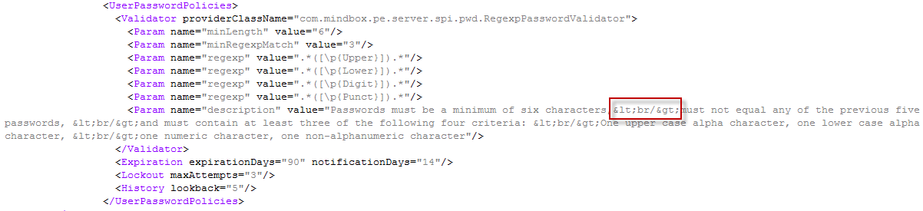

Figure 1: Excerpt from PowerEditorConfiguration.xml (a server file)

# Upgrade Instructions

## Upgrading from Version 5.9.5

Upgrading from 5.9.5 requires installation steps on both the server machines and all client machines. The below table lists elements that you will need to make edits to for this upgrade.

| **PE Element** | **Changed** | **Notes** |
| --- | --- | --- |
| PowerEditor WAR File | Yes | See Section *2.1.1 Server Upgrade Procedure* |
| Database | No |  |
| PowerEditor Configuration XML file | Yes | *See Section 1.4 Known Issues and 2.1.1.1 Update PowerEditorConfiguration.xml* |
| web.xml | Yes | See *Section 2.1.1.2 Update web.xml* |
| Domain XML file | No |  |
| Parameter XML file | No |  |
| MMS Changes | No |  |
| Other – Client Access Changes | Yes | See *Section 2.1.2 Client (User) Upgrade Procedure* |

### Server Upgrade Procedure

You can simply follow the standard upgrade instructions as outlined the *PowerEditor Installation and Customization Guide.* Specifically, see *Section 4: PowerEditor Server Upgrade Procedures* of that document.

In summary,

1. Backup everything
2. Update your PowerEditorConfiguration.xml. See below.
3. Shutdown Application Server (e.g. Tomcat, WAS, etc.)
4. Replace your old powereditor.war file with the new version
5. Update powereditor/WEB-INF/web.xml – See *Section 2.1.1.2 Update web.xml*
6. Re-start Application Server.

### Update PowerEditorConfiguration.xml

Start with your existing PowerEditorConfiguration.xml.

In the <Server> section of your existing configuration file, add an entry that reflects the URL that Power Editor users would normally reference for the Power Editor. This entry will be used by the Power Editor Server to launch the Java client application. The reference can reflect an actual server or virtual URL.

<Hostname>DevPowerEditor.corelogic.com</Hostname>

### Update web.xml

Start with the new version the web.xml file which is bundled within the new powereditor.war. The web.xml file is located in within the war file under:

powereditor/WEB-INF/web.xml

You’ll need to extract this web.xml from powereditor.war, then edit it.

This file can be extracted from powereditor.war in various ways – e.g. using your Application server or using an extraction tool like *7-ZIP*.

After you’ve extracted the new web.xml, you’ll need to edit the new web.xml, and indicate the location of your PowerEditorConfiguration.xml file.

<context-param>

<param-name>ConfigurationFile</param-name>

<param-value>C:/MindBox/PowerEditor/config/PowerEditorConfiguration.xml</param-value>

</context-param>

### Desktop Upgrade Procedure

Now that you’ve installed the PowerEditor server, you’ll need to upgrade the desktop access to the PowerEditor. There are two steps in upgrading each user of the PowerEditor

1. Update Security Certificate
   * See *Appendix 1: Client Certificate Update Instructions*
2. Update Desktop Access

To set up end users’ desktop access, the easiest approach is to create a batch file with the following:

javaws http://*HOSTNAME*:*PORT*/powereditor/PowerEditor.jnlp

where *HOSTNAME* matches the Hostname entry in the Power Editor configuration file (see previous section) and *PORT* reflects the Port under which the Power Editor runs in the Web Server.

Place this batch file on a user’s desktop (any location will work) and have them use it to start the Power Editor.

## Upgrading from Versions Older Than 5.9.5

If you are upgrading from PE version older than 5.9.5 please refer to *PowerEditor Version 5.9.5 Release Notes*. Once the upgrade to 5.9.5 is successful, continue with instructions in this document.

# PowerEditor User Release Notes

## Launching PowerEditor

Your system administrator will have installed an icon that launches the PowerEditor. Use this instead of opening a web browser to start the PowerEditor. A temporary dialog will display while the PowerEditor is downloaded (your URL will differ)

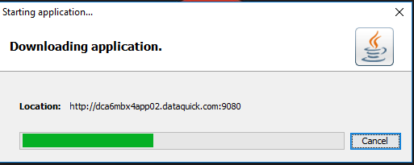

and another while it is validated.

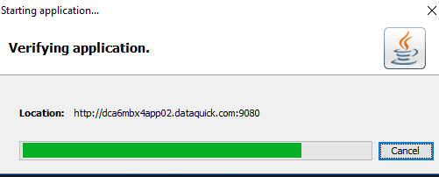

It is possible the download and verification are fast enough so that you may not see either of these dialogs.

## Login Dialogs

You’ll notice that the login dialogs look different, although they have the same basic functionality.

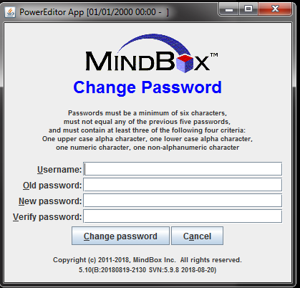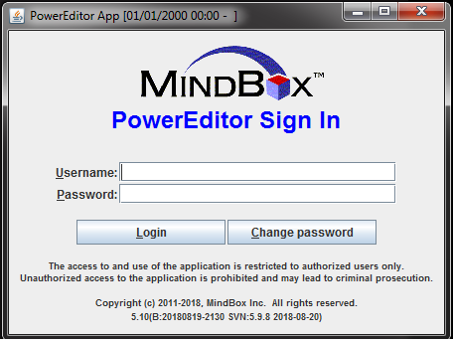

## Updated non-expired Certificate for PowerEditor Application

If you get a security warning when launching the PowerEditor, your system administrator should help you update your desktop to use a security certificate (Instructions included below in Appendix 1).

## Date-Picker Limitations

You might notice that editing a date *within guideline grids* no longer brings up a date selection dialog. In this case, you can simply type in a date within this grid. Note that date-pickers work everywhere else (e.g. Activation Dates, Date Synonyms, etc.) It is only within a grid that the date-picker is disabled.

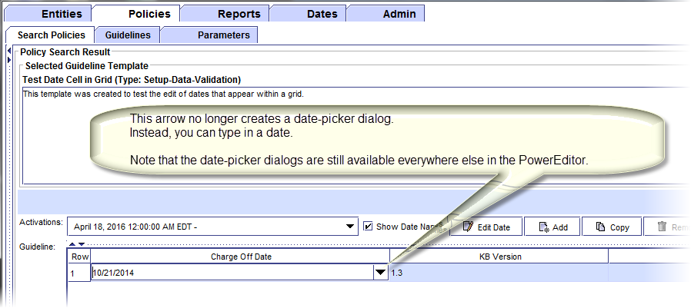

Editing columns defined as a *date range* with guideline grids continue to use a date selection dialog.

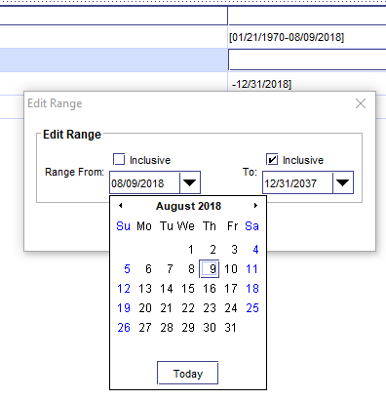

# Appendix 1: Client Certificate Update Instructions

Each Power Editor user should receive a certificate file named pe_pubCert.cer.rename

Rename the file to pe_pubCert.cer

For each Power Editor user,

Go to their Java Control Panel (Java from Control Panel)

Select the Security tab:

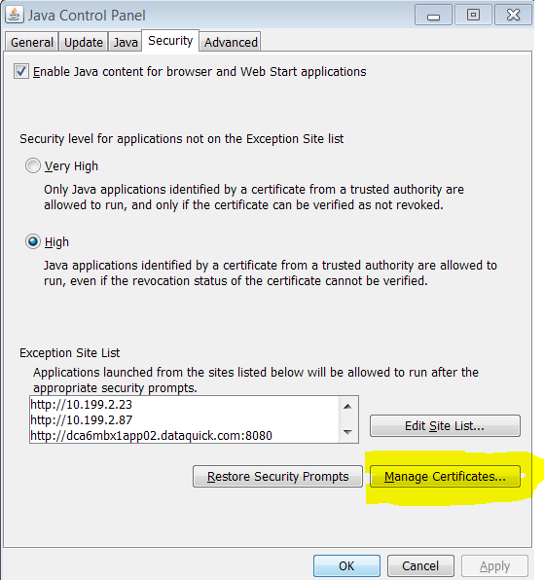

Select the Manage Certificate button

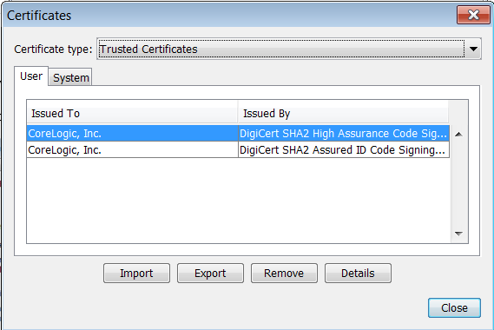

Select Import button

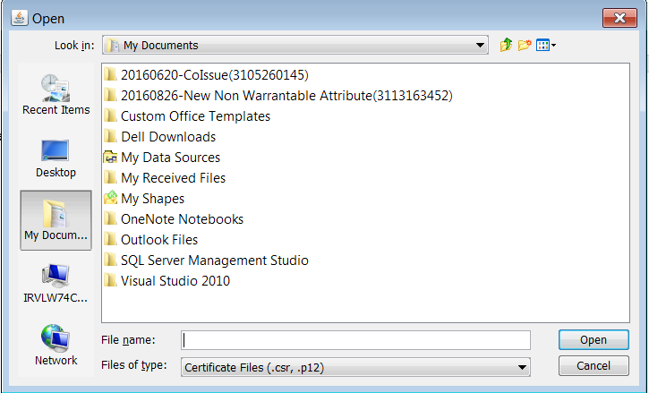

Change the file type to *All Files*, then navigate to the folder where the Certificate is.

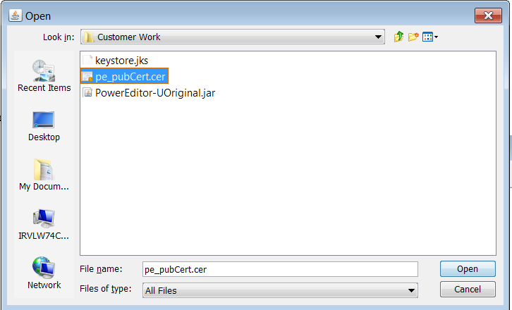

Choose the file pe_pubCert.cer, and select Open, which should place the Certificate into the dialogue:

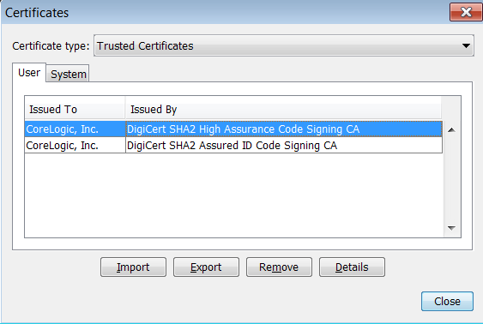

Select the Certificate that has “Issued By” as “DigiCert SHA2 High Assurance Code Signing CA” and “Issued To” as “CoreLogic, Inc.”. Then select the Details buttons:

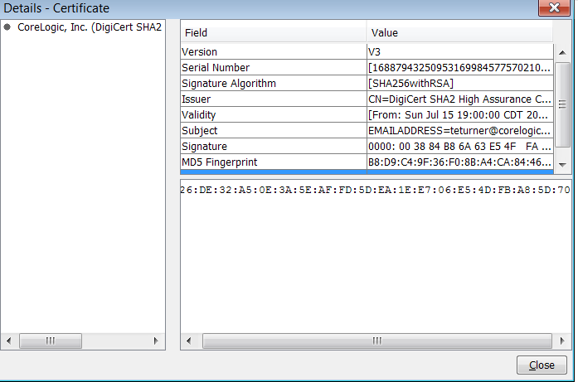

Select the row with Validity – it should have dates that are from Jul 15 2018 until Aug 11 2021. If these dates are not there, and you have two certificates with Core Logic, try the other Certificate:

